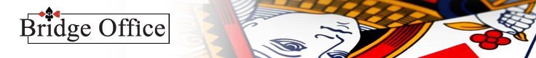

© Bridge Office - www.bridgeoffice.nl - info@bridgeoffice.nl
Reply Card
Belonging to booklet:

Game | Bid | Right/Wrong
1
2
3
4
5
6
7
8
9
10
11
12
13
14
15
16
17
18
19
20

