Bridge Office Resultaten Ultra Light

A program to create a result for a bridgame.
To use the program is as easy as possible.

1. Enter and save names.
2. Create group based on the names and save.
3. Choose the number of rounds and games.
4. Choose the play scheme.
5. Choose if put in the score by round or by game..
6. Click start.

The result that can be calculated is of course visualized and you can print it.

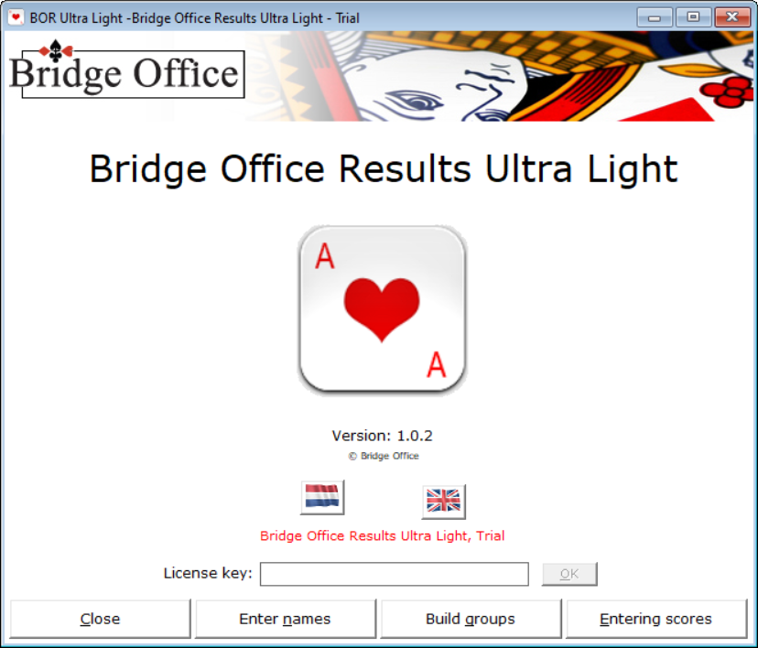

You have downloaded Bridge Office Results Ultra Light and it is working with the trial version.
You can always update this trial version to a work fully working version. If you purchase a license key, all options of Bridge Office Results Ultra Light will be opened.
Content
License key 3
Enter names 6
Entering scores 25
Enter scores per game 29
Enter scores per round 36

License key

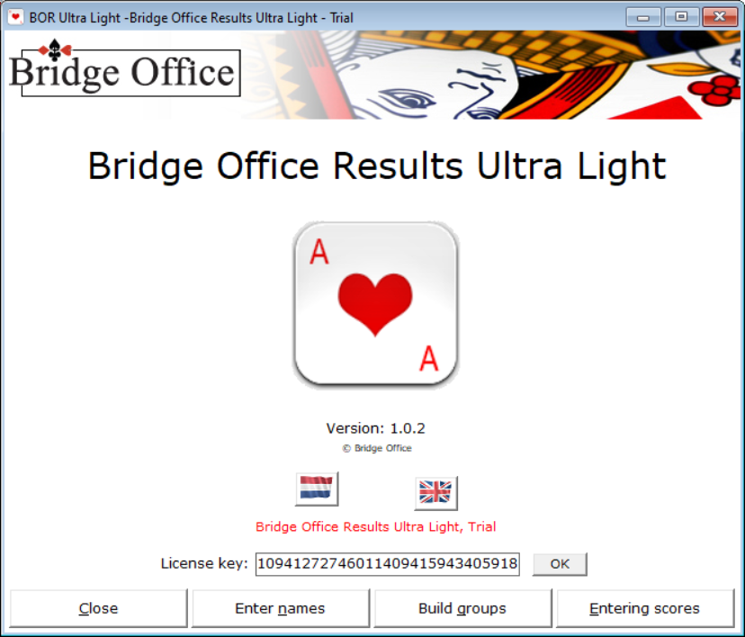

The license code will be sent to you by e-mail.
Select the license key in your mail and copy it.
Launch Bridge Office Results Ultra Light and right-click in the box behind License Key: and then choose Paste from the menu. The license key is now in the text field and the OK button becomes active.
Click the OK button.

Click the OK button and you can use Bridge Office Results Ultra Light in its entirety.
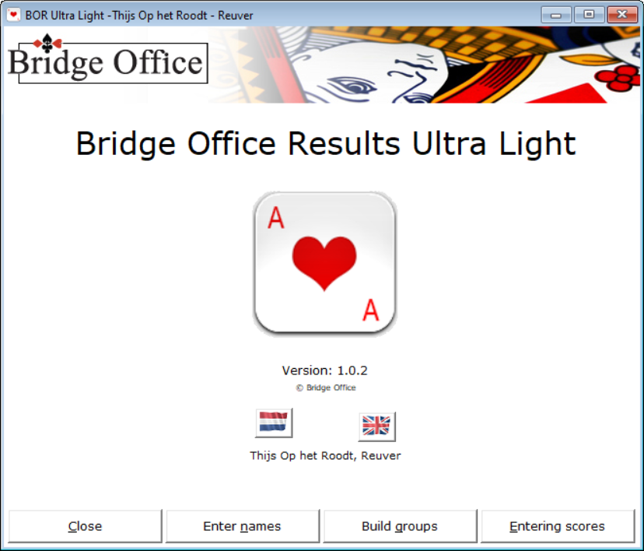

The Exit button will be clear. But also important to know is that you close each screen with the ESC key. Also this screen. Here you close the program with the ESC key.
I assume that the buttons Delte, Empty list and Print, need no further explanation.
Also the checkbox Sort from High to low that this also speaks for itself.

Update of Bridge Office Results Ultra Light
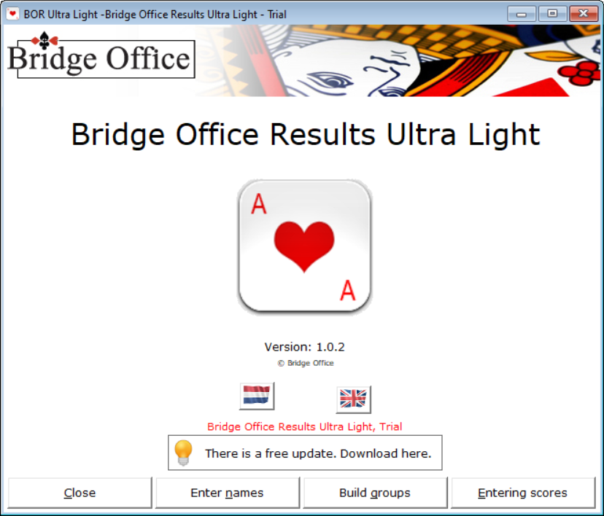
The updates for Bridge Office Results Ultra Light are free.
When an update appears, data does not always mean that it is an update of the program. It may also be that I have added new schedules.
Click in the box where a new update is reported.

Bridge Office Results Ultra Light will download the update first.
Then Bridge Office Results Ultra Light will shut down on its own and start the update.
On my website it says whether adjustments have been made to the program or whether it concerns new schedules.

Enter names

The entry of the names has also been kept as brief as possible.
The following are needed:
Title (Mr. or Mrs.) (TICK).
First name or Initial(s).
Surname.
If it is the case that several players have the same name, you have to come up with something for it.
For example, to add the last name (1) and (2).
For example: Mr. Jan Jansen (1) and Mr. Jan Jansen (2)
As soon as you have entered a first name and a last name, the Add button becomes active.

Click the Add button. Fill in all your names.

If you want to remove a name from the list or make changes to it, click the name in the list.

If you click Yes, the name will be permanently removed from the list.
If you click No, the Title will be checked, the first name and the last name will be placed in the relevant text frame.
You can then change whatever you want.
After that, click the Add button.

If you have entered the names, we will save the list.
In this manual I use My names as the file name.

After File Name, type the file name, how you want to name your name file.
The Save button becomes active. Once you have entered the name, click the Save button.

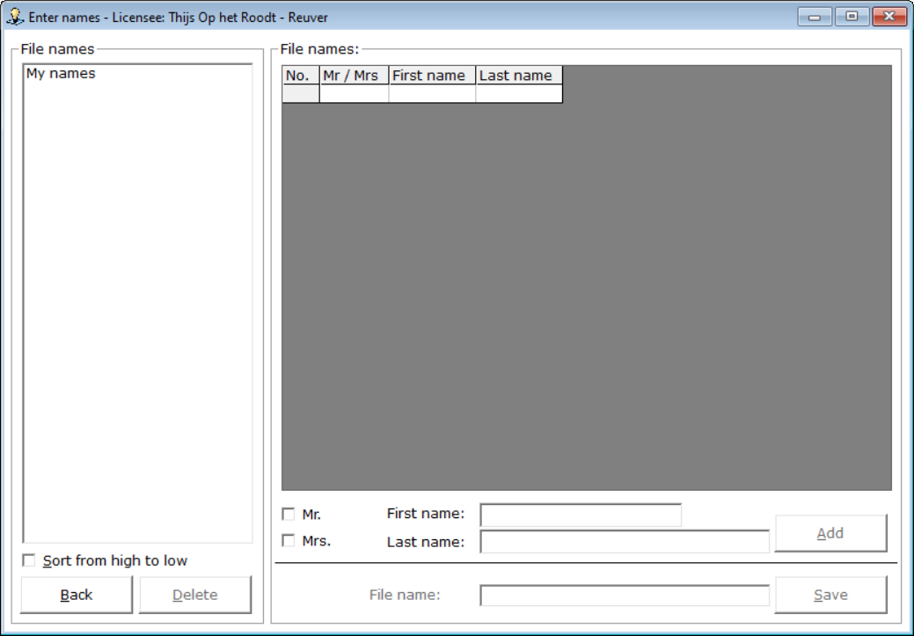
The list of names has been saved and the list on the screen has been cleared.You can create as many name files as you want.If you want to change something, after you have saved the name list, select the file on the left.

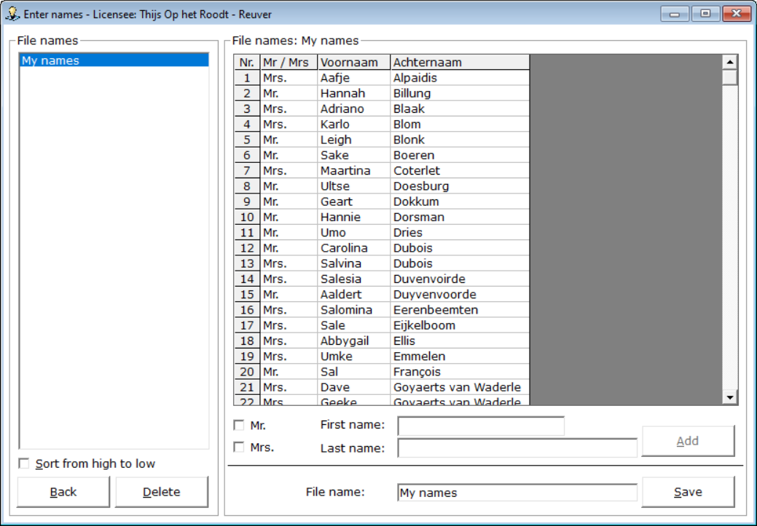

The names from the chosen name file are displayed in the list.
Click remove the name you want to change, or enter a name to add it to the list.
When you're done with the change, click the Save button.

If you click Yes, the old file will be overwritten.
If you click No, you will return to entering names and you can rename the name file.
You can delete a name file by clicking it on the name file in the left list.
The Clear button becomes active. To delete the chosen name file, click the Delete button.

Bridge Office Results Ultra Light will give you the following message.

Do you Click Yes, the name file will be permanently deleted from your hard disk.
If you click No, nothing will happen. You will return to entering the names.

When you have finished entering the names and saved the file, click the Back button.
You will return to the home screen.
Build groups
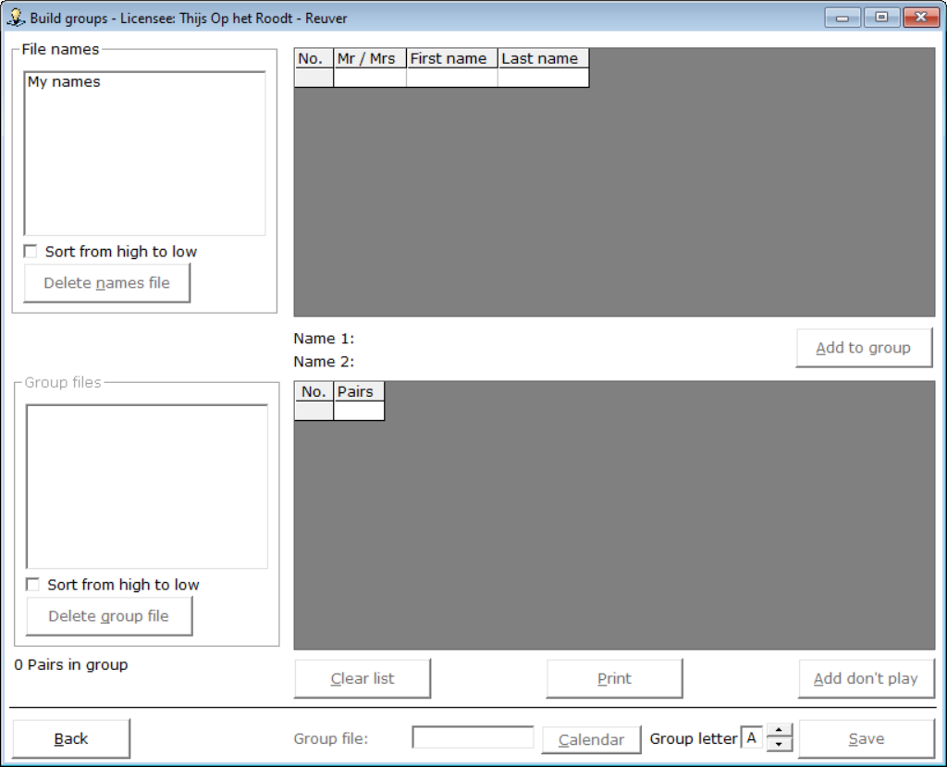

Before I explain how it works, just a little about the screen that you see.
The screen is divided into two parts. A part above and a part below.
The upper part of the screen only has to do with names.
The section below is about the group you are going to put together.

You can only build one group per date. However, you can customize the Group letter.
For example, you can create a group file named 14-03-2022_Group_A and a group file named 14-03-2022_Group_B.

Between the two sections on the screen you will see Name 1: and Name 2: without you being able to fill in anything.
That was deliberately chosen. You must work with a names file if you want to be able to build a group.

Click the names file that you want to use in the upper-left corner of the list.

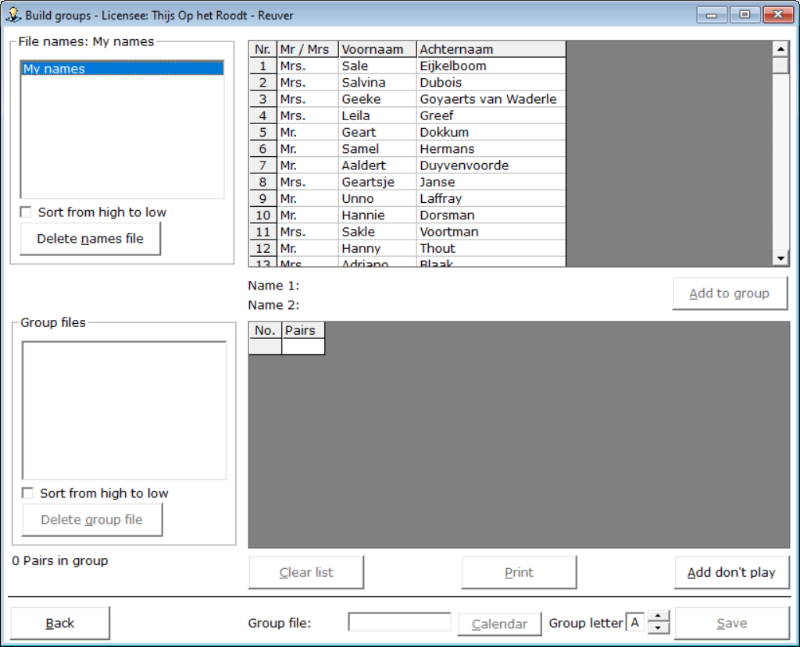

The names in the names file are shown in the upper right part.
Click on the first name that belongs to first pair.
The name is placed after Name 1:.
Now click on the second name that belongs to first pair.
The name is placed after Name 2:.
Now the button, Add to group, to the right of the names becomes active.
Click the Add to group button.
The names are now added to the list in the lower part of the screen.
Then click the Add button.
Error in the composition of the group or on a pair should get another number.
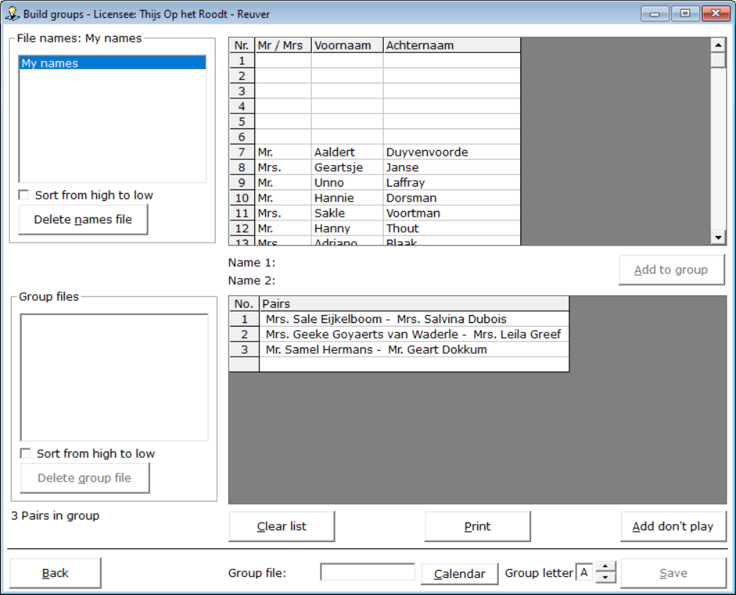
Click on the pair in the bottom list.

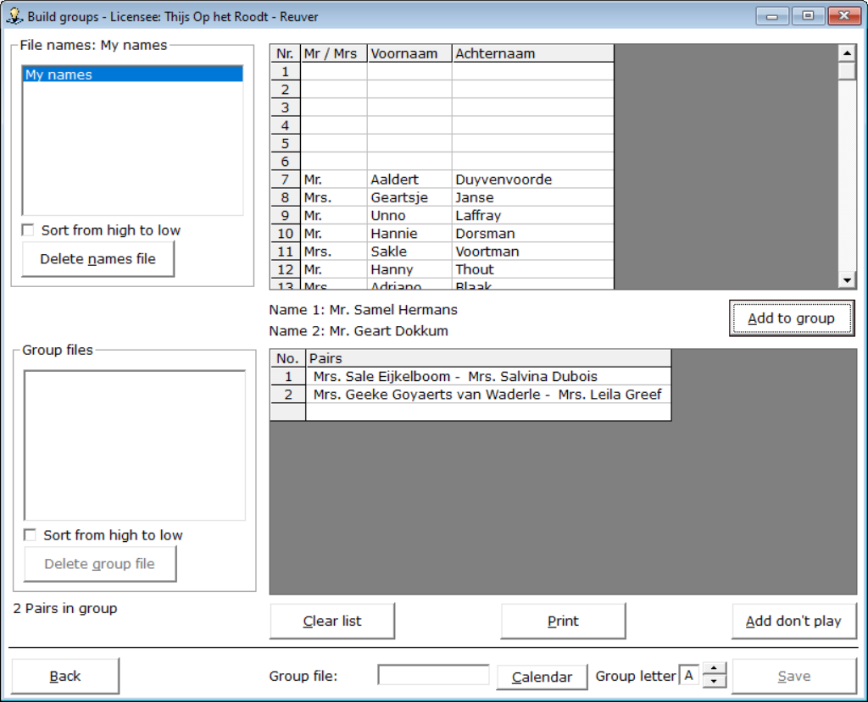

Now click on the name, after Name 1: or Name 2:
The name is placed back in the list of names.
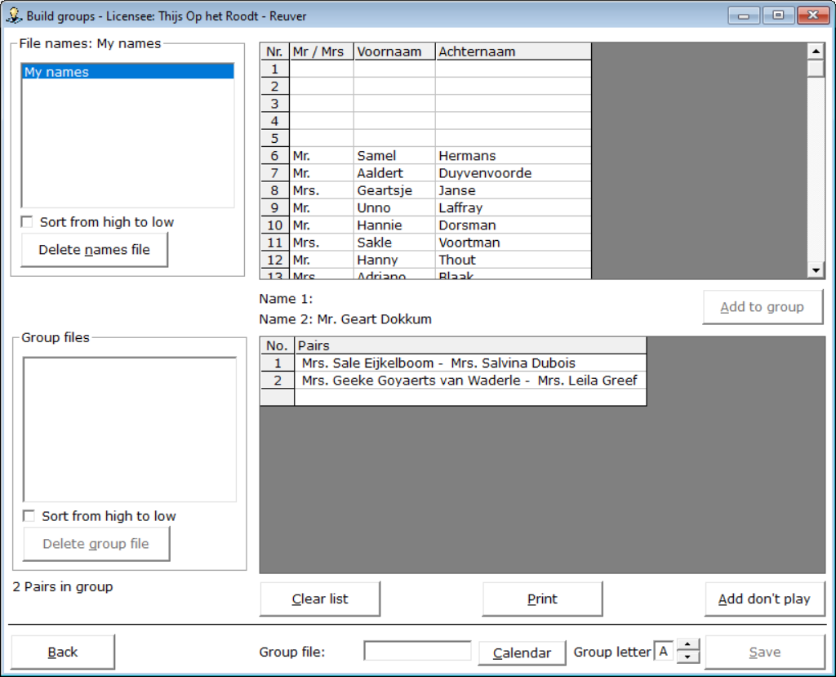

You can do the same now, with the middle name.
Just click on it and the name will be placed back.

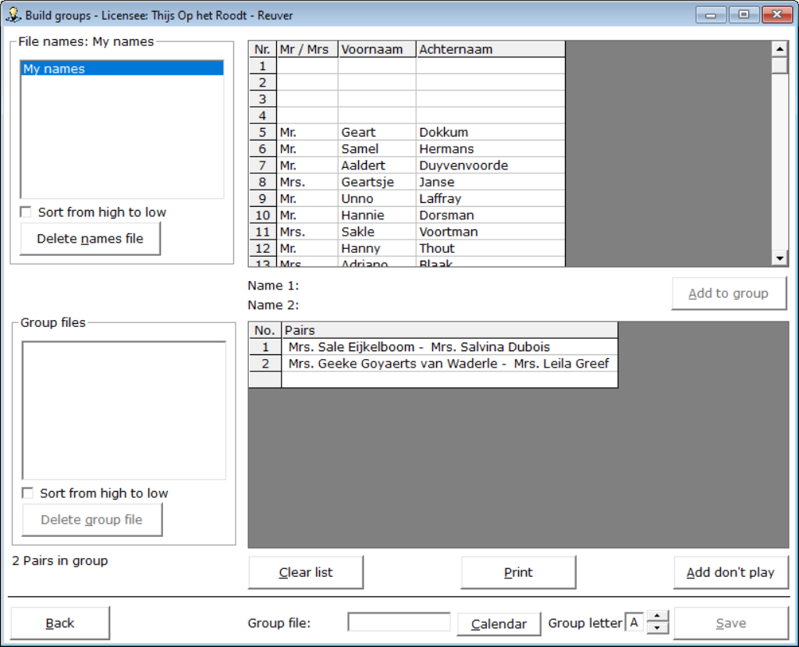

You can continue to put together the group.
At the bottom left it is reported how many pairs you are in this group.
Click on the name in the top list to start composing pair 2.
Click the second name for pair 2, and then click the Add to Group button again.

You can add a Pair that is absent by clicking the Add don't play button.
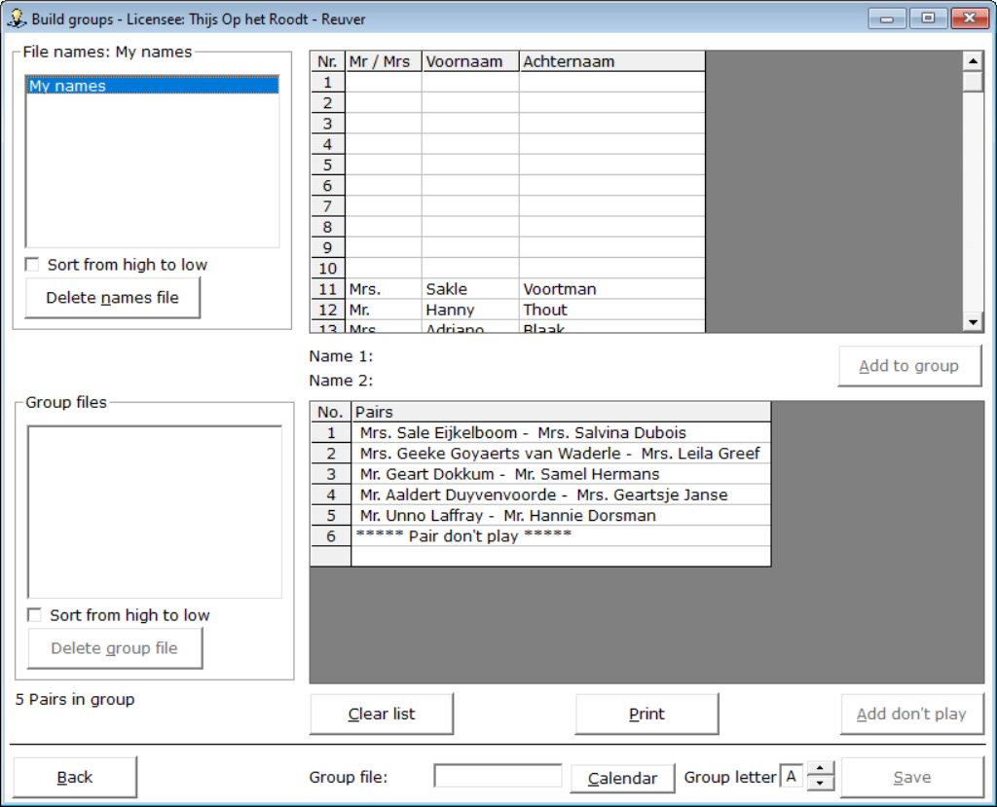

Despite the fact that the Don' play pair is actually pair number 6, 5 Pairs in group is reported at the bottom left. But now it's getting a little bit important. Suppose you add a few more, because you just want to move on. That is not a problem, but then you have a total of an odd number of pairs and a pair don't play. That is not possible. As soon as you add a Pair don't play, the group must always have an even number of pairs.

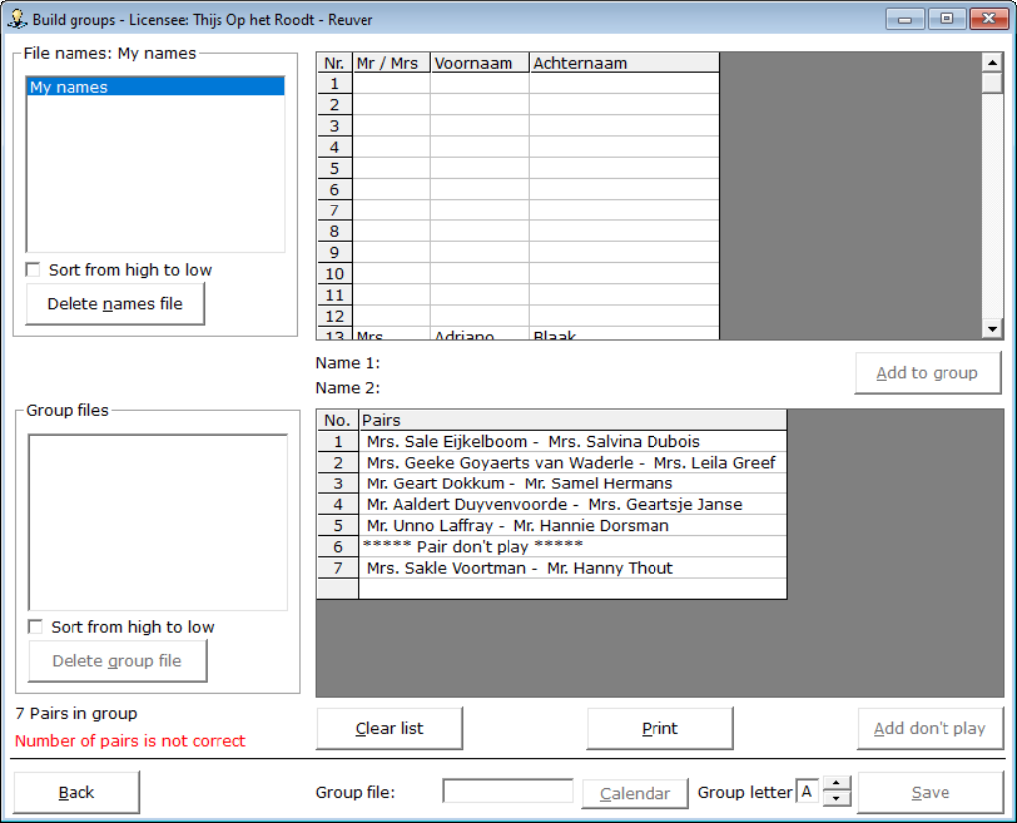

Bridge Office Results Ultra Light reports at the bottom left that the number of pairs is not correct in the group.
You also cannot save the group file now. You must add at least one more pair to the group.

Now, of course, it may be that you want to use the highest pair number as a Pair don't play.
That is also possible, but then you do not have to add it.
Bridge Office Results Ultra Light will recognize that the number of pairs is an odd number and will use the last pair number as a pair don't play.
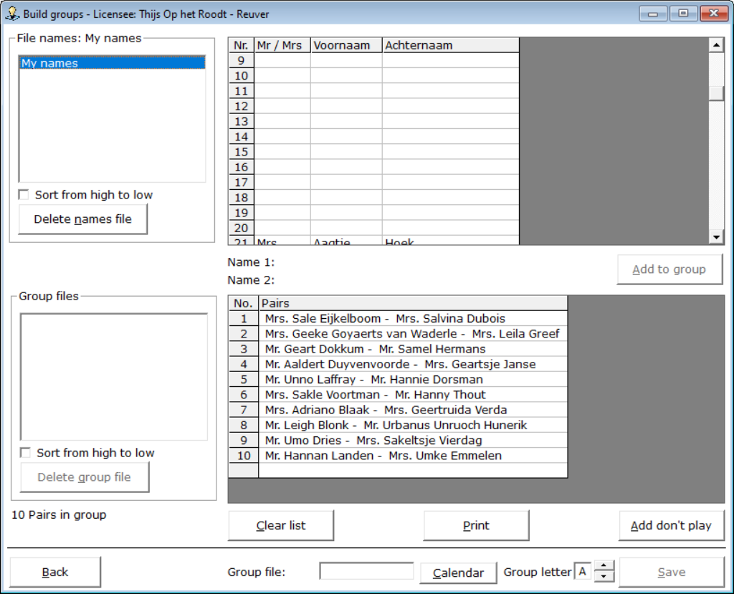

To save a group file, you MUST choose a date.
You cannot enter it yourself, but to do so, click the Calendar button.
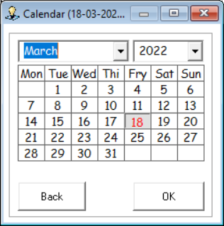

Choose your date and click the OK button.
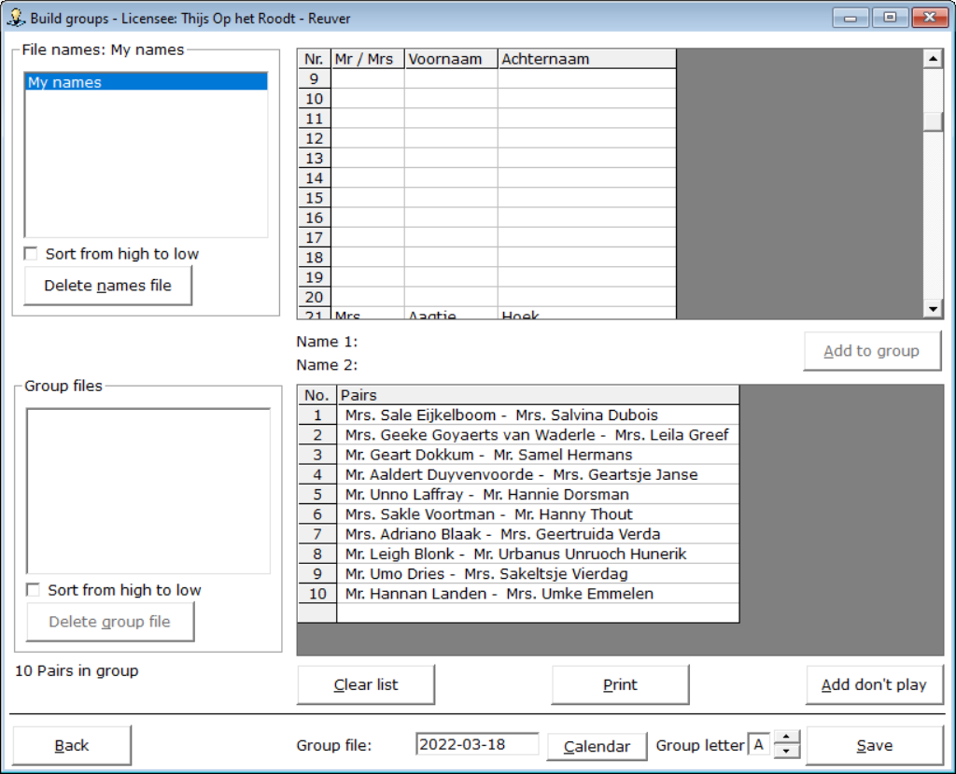

You can now customize the group letter. This allows you to have multiple groups play on one date.
If you have set the group letter correctly, click the Save button.

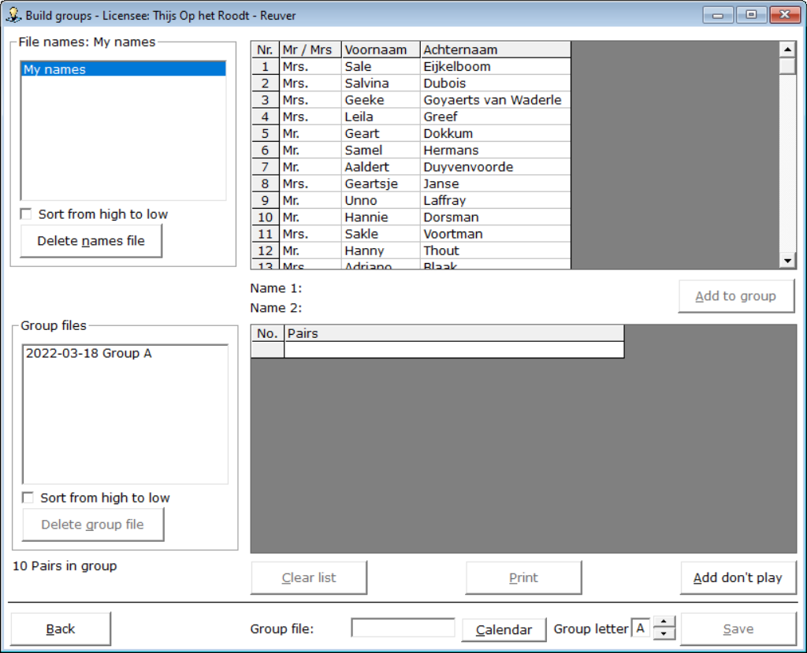

The group file has been saved and is shown in the lower part on the left side of the screen.
The names file has been replenished and if you wish, you can now create a second and third group.

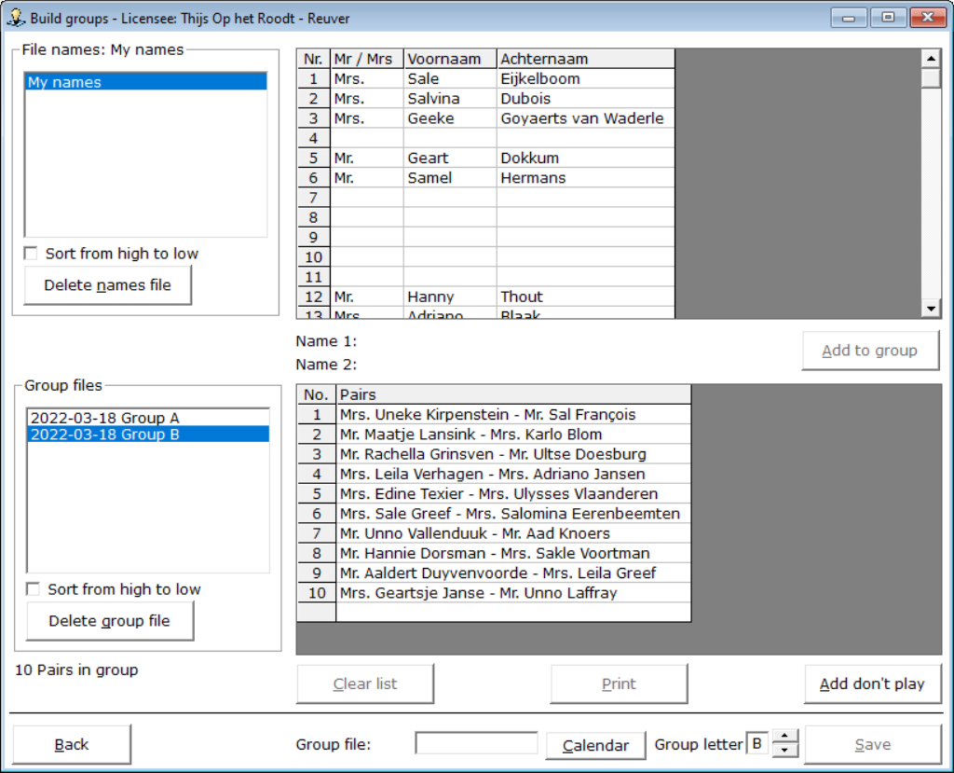
If you want to delete a names file, you will receive the following message.

If you want to delete a group file, you will receive the following message.

When you have finished composing the group(s), click the Back button.
You will return to the home screen.

Entering scores

We always come into the screen below, which I have called Preparation.
Bridge Office Results Ultra Light needs to know a few more things about you before you can start entering the scores.
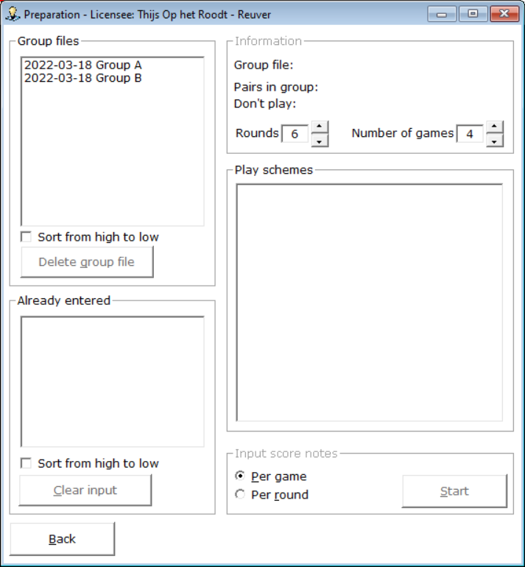

Bridge Office Results Ultra Light now wants to know which group of file you are going to work with, because then he knows how many pairs are in the group and whether there is a don't play pair in the group. Then Bridge Office Results Ultra Light no wants to know how many rounds you play and how many games you play per round. Based on this, Bridge Office Results Ultra Light will show you one or more play schemes schedules from which you should choose your scheme, by clicking it.Als laatste wil Bridge Office Results Ultra Light wants to know how you want to enter the scores.
At the end of the afternoon or evening (Per game) or after each round (Per round).
You can no longer change the choice you make now. So you can't start entering per round and then afterwards think: Well. Per game was easier. It is possible, but then you must first delete the data already entered in the list Already entered.
Then you start from scratch again.
If you have chosen everything, so that Bridge Office Results Ultra Light can get started and also with entering the scores, the Start button will be active. Then click on the Start button.

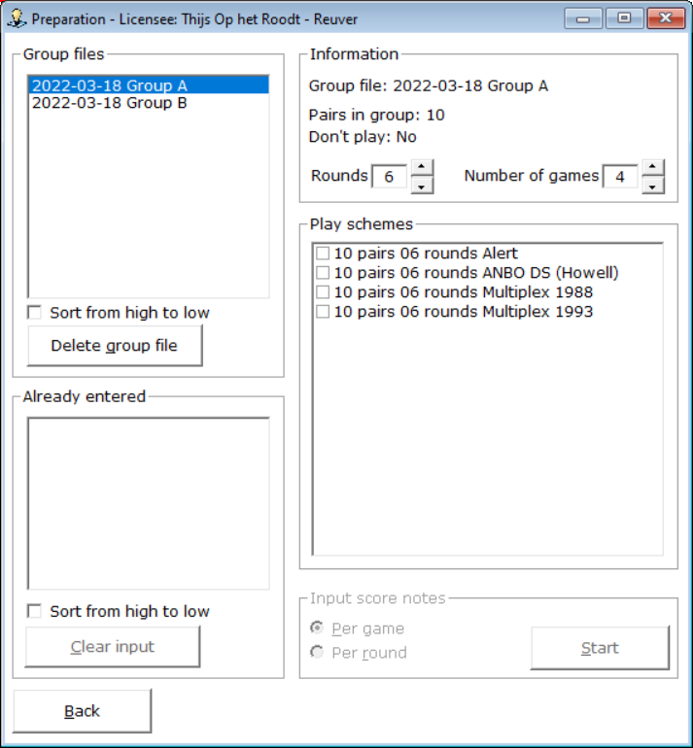

The file group has been chosen.
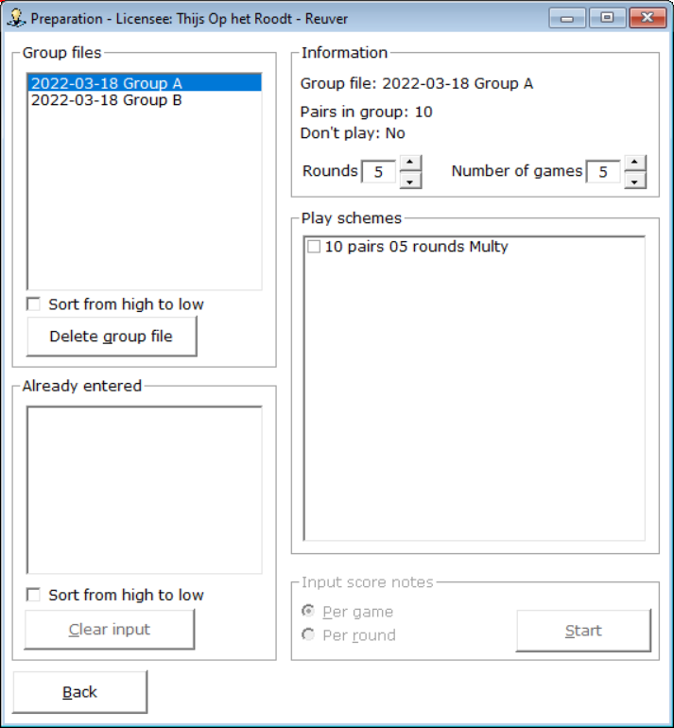

The number of rounds and the number of games is chosen.
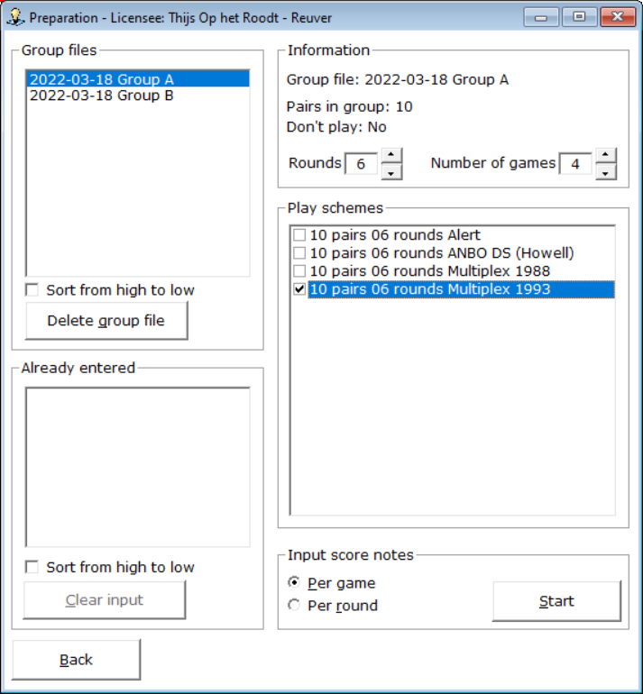

The schemahas been chosen and input per Score has been chosen.
Now you can click the Start button and start entering.

Enter scores per game
On the left are the game numbers. You do not have to enter the games in order. This can be done randomly. At the bottom of the screen is already some information about certain inputs.

Once you've entered the scores for a game, the Done button becomes active.
If you click on it or press the letter D, the mp for the pairs will be calculated and placed in the list at the bottom of it.
You can now enter the next game by clicking on the relevant game number at the top left.
If for some reason you can't enter all the games at once, that's no problem.
Click on the Back button and you will be back in the preparation screen.

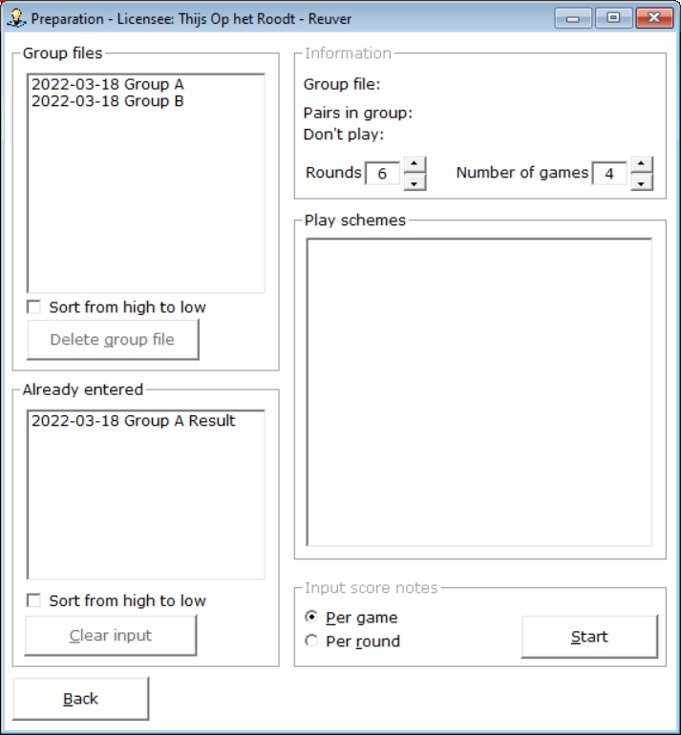

What you hopefully notice is that in the list at the bottom left (Already entered) is your group file with Result behind it. Now you don't have a result yet, but Bridge Office Results Ultra Light has saved everything you entered and everything you've set up for this group. You can continue with the input, so to speak, the following week.
Do you want to continue with the input you were working on.
Then click in the Already Entered list on the relevant date.

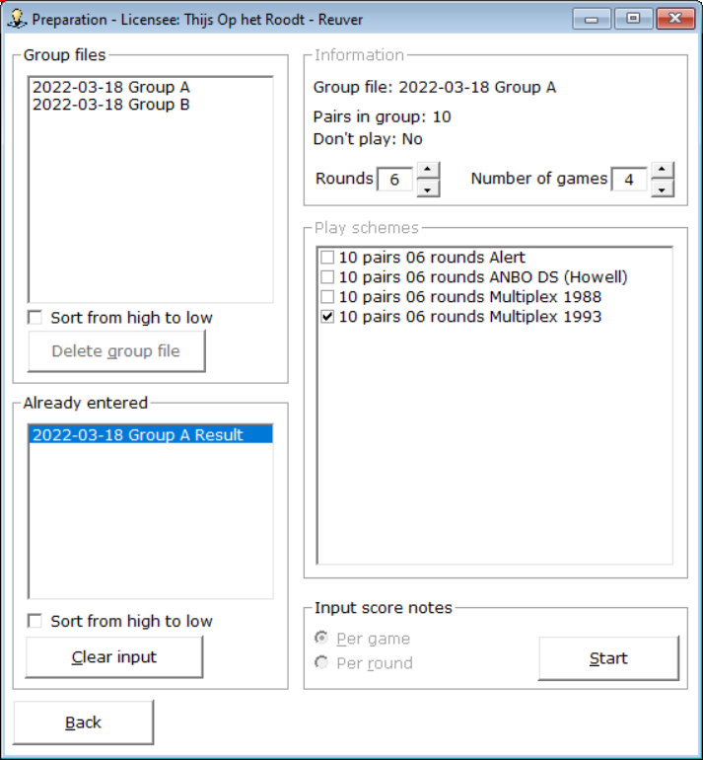

Bridge Office Results Ultra Light has filled in your setting that you created for this group and you cannot change it. Click the Start button and you can continue entering.

If you have a Contra seat, click on the NZ pair.
You will then receive the following question.
If so, click Yes.
If you click No, Bridge Office Results Ultra Light does nothing.

Do you want to undo the change of pairs?
Then click on the NZ pair again and you will get the next question.

If you click Yes, pair numbers will be changed again.
If you click No, nothing will happen.

All games have been entered. Now the Result button becomes active.
Click the Result button.
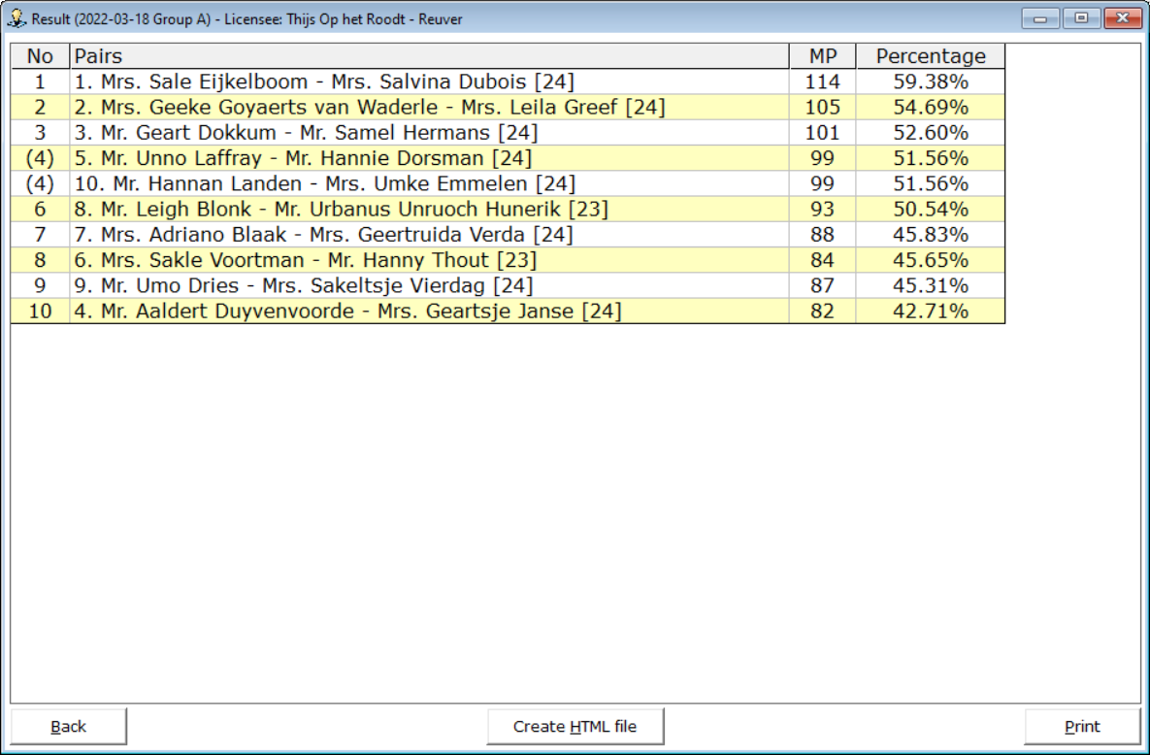

You have the results. You can print it or create a THML file.
The number between [23] indicates how many games the pair has played.
By clicking on the back button in this screen, you will go to the input screen.
Click on the Back button there and you will go to the Preparation screen.

Enter scores per round

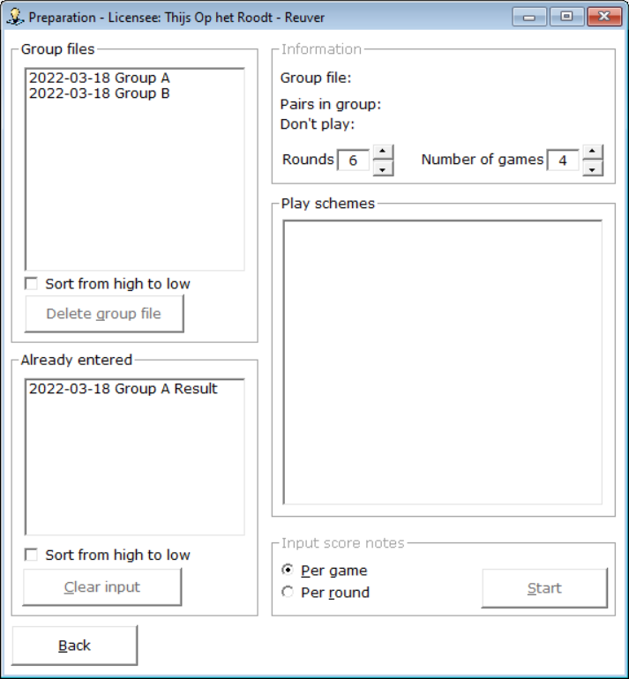

If you now try to use the group file 13-03-2022 Group A again, you will receive the following message.

If you want to use this group again, you must first delete the file 13-03-2022 Group A.
You can then choose the group again and make other settings.

We now choose group 13-03-2022 Group B

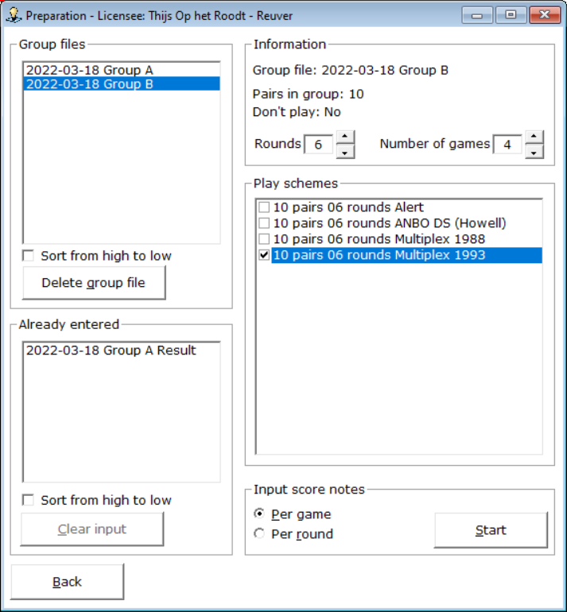

Everything is set up well, only we want to Enter scores Per round.
Select Per Round, and then click the Start button.
On the left are the rounds.
You do not have to enter the rounds or score slips in order. This can be done randomly.
At the bottom of the screen is already some information about certain inputs.
The scores slips as they are offered is on table number.
Above, pairs 1 and 2 are on table 1, pairs 3 and 4 on table 2, etc..
Just like with the input of games, we always enter the score of North-South.
If you have filled in the score slip of table 1, the Done button will become active.
You can click on that, but you enter the letter D.
In both cases, you will get the following score slip. You must do this after each score slip entered.
First on Done and then the next slip. Otherwise, the entered scores will not be saved.

Bridge Office Results Ultra Light has now put your entered scores in the list at the bottom of the screen. You can now enter the following score slip. Don't forget to click Done.

If you have a contra seat, click (in this example) with the right mouse button 3 -4 (5-8)
Bridge Office Results Ultra Light will then give you the message below.

By right-clicking on 3 -4 (5-8) again, you will restore the pair numbers.
If there is an arbitral score, you enter 65% in the score of North-South, for example.
Bridge Office Results Ultra Light then fills the same score at East-West.
You can then change the score of East-West to, for example, 35%.

With a contra sit, Bridge Office Results Ultra Light gets a problem with playing schedule.
Bridge Office Results Ultra Light cannot enter the score entered in the sheet.
He does, however, place the pairs well. A button will appear at the top right with the inscription Not Yet Done.
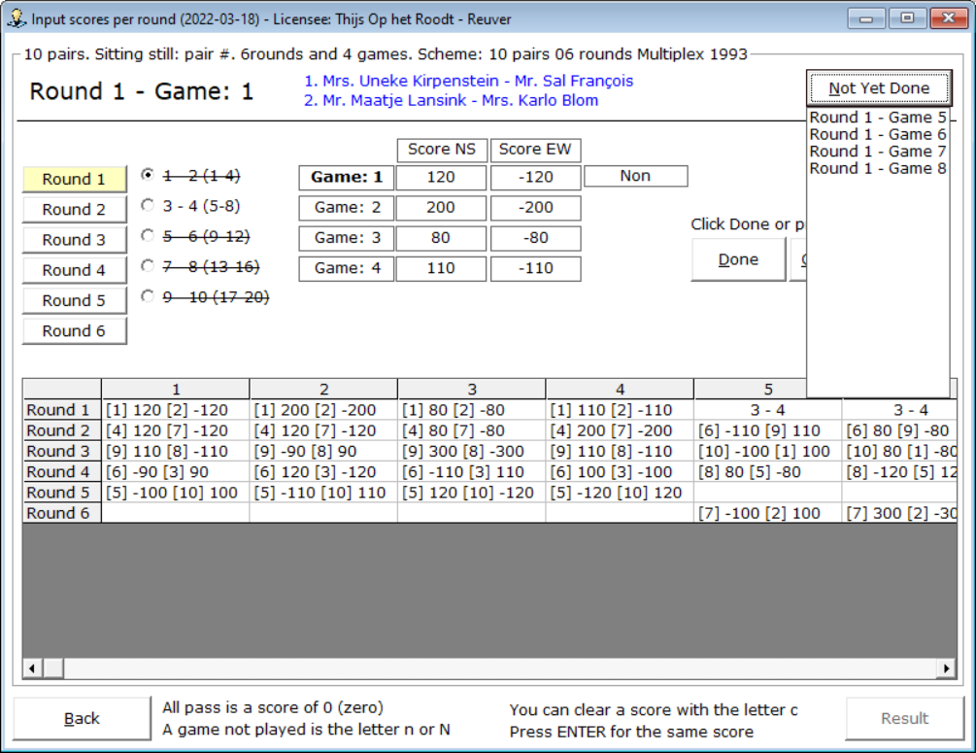
Click the button with the mouse and hold down the mouse button.

You will then see the rounds and the games that have not yet been entered.
If the slip has already been entered, click once on the first score of North-South and press the Enter key.
The Done button will then become active. Click on it and the score slip will be placed in the list.
Once all scores have been entered, the Result button will be active.
Click the Result button.
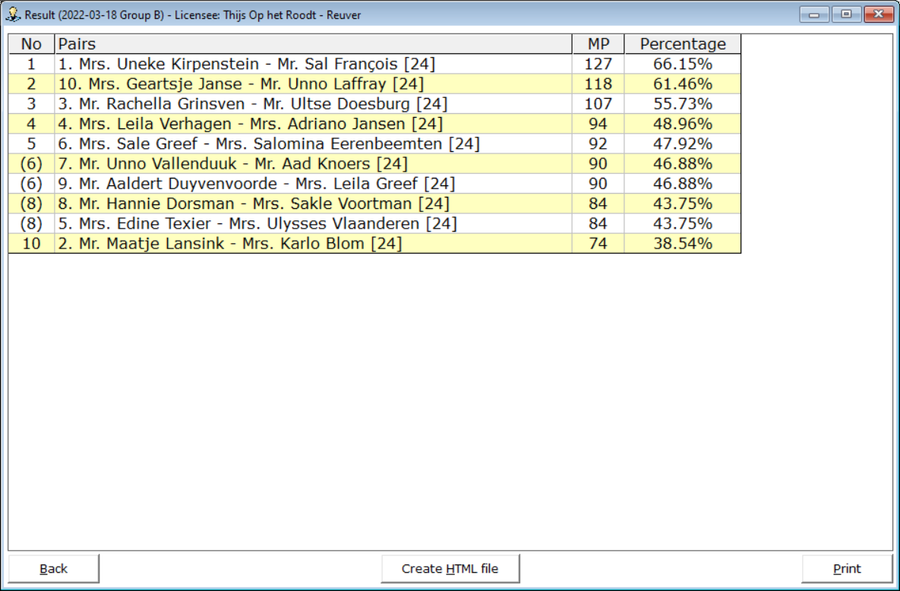
You can print the results and have them made into an HTML file.

The rest is all the same as when entering the games.

