Bri dge Office

puntje 2.wmf



Biedboekje 05 - Openen  
  
  
© Bridge Office

Auteur: Thijs Op het Roodt

|  |  |
| --- | --- |
| Wij | Kwetsbaar |
| Zij | Niet kwetsbaar |

Als er niets over de tegenstanders wordt geschreven,  
dan passen ze beiden op alles.

|  |  |  |  |
| --- | --- | --- | --- |
| 1 | 14 punten | Wij | Zij |

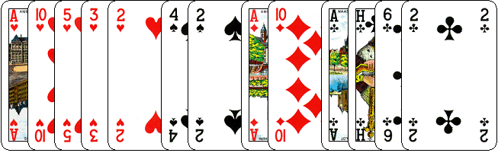

|  |  |  |  |  |
| --- | --- | --- | --- | --- |
| 1♣ | 1♦ | 1♥ | 1♠ | 1 SA |
| 2♣ | 2♦ | 2♥ | 2♠ | 2 SA |
| 3♣ | 3♦ | 3♥ | 3♠ | 3 SA |
| 4♣ | 4♦ | 4♥ | 4♠ | 4 SA |
| 5♣ | 5♦ | 5♥ | 5♠ | 5 SA |
| 6♣ | 6♦ | 6♥ | 6♠ | 6 SA |
| 7♣ | 7♦ | 7♥ | 7♠ | 7 SA |
| Pas | DB | RDB |  | |

|  |  |
| --- | --- |
| Hoe opent u deze hand? | Omcirkel uw bod |

|  |  |  |  |
| --- | --- | --- | --- |
| 2 | 14 punten | Wij | Zij |

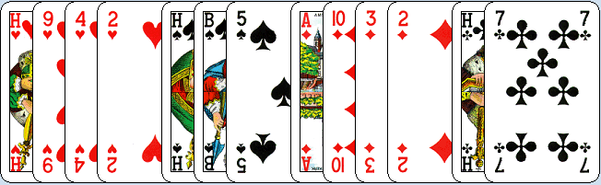

|  |  |  |  |  |
| --- | --- | --- | --- | --- |
| 1♣ | 1♦ | 1♥ | 1♠ | 1 SA |
| 2♣ | 2♦ | 2♥ | 2♠ | 2 SA |
| 3♣ | 3♦ | 3♥ | 3♠ | 3 SA |
| 4♣ | 4♦ | 4♥ | 4♠ | 4 SA |
| 5♣ | 5♦ | 5♥ | 5♠ | 5 SA |
| 6♣ | 6♦ | 6♥ | 6♠ | 6 SA |
| 7♣ | 7♦ | 7♥ | 7♠ | 7 SA |
| Pas | DB | RDB |  | |

|  |  |
| --- | --- |
| Hoe opent u deze hand? | Omcirkel uw bod |

|  |  |  |  |
| --- | --- | --- | --- |
| 3 | 14 punten | Wij | Zij |

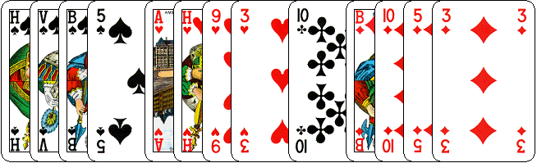

|  |  |  |  |  |
| --- | --- | --- | --- | --- |
| 1♣ | 1♦ | 1♥ | 1♠ | 1 SA |
| 2♣ | 2♦ | 2♥ | 2♠ | 2 SA |
| 3♣ | 3♦ | 3♥ | 3♠ | 3 SA |
| 4♣ | 4♦ | 4♥ | 4♠ | 4 SA |
| 5♣ | 5♦ | 5♥ | 5♠ | 5 SA |
| 6♣ | 6♦ | 6♥ | 6♠ | 6 SA |
| 7♣ | 7♦ | 7♥ | 7♠ | 7 SA |
| Pas | DB | RDB |  | |

|  |  |
| --- | --- |
| Hoe opent u deze hand? | Omcirkel uw bod |

|  |  |  |  |
| --- | --- | --- | --- |
| 4 | 15 punten | Wij | Zij |

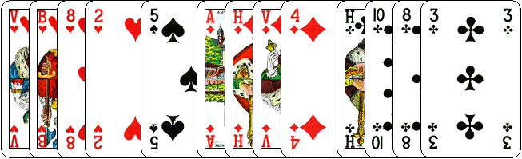

|  |  |  |  |  |
| --- | --- | --- | --- | --- |
| 1♣ | 1♦ | 1♥ | 1♠ | 1 SA |
| 2♣ | 2♦ | 2♥ | 2♠ | 2 SA |
| 3♣ | 3♦ | 3♥ | 3♠ | 3 SA |
| 4♣ | 4♦ | 4♥ | 4♠ | 4 SA |
| 5♣ | 5♦ | 5♥ | 5♠ | 5 SA |
| 6♣ | 6♦ | 6♥ | 6♠ | 6 SA |
| 7♣ | 7♦ | 7♥ | 7♠ | 7 SA |
| Pas | DB | RDB |  | |

|  |  |
| --- | --- |
| Hoe opent u deze hand? | Omcirkel uw bod |

|  |  |  |  |
| --- | --- | --- | --- |
| 5 | 12 punten | Wij | Zij |

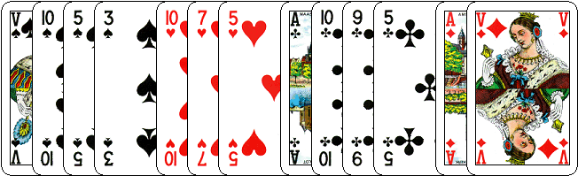

|  |  |  |  |  |
| --- | --- | --- | --- | --- |
| 1♣ | 1♦ | 1♥ | 1♠ | 1 SA |
| 2♣ | 2♦ | 2♥ | 2♠ | 2 SA |
| 3♣ | 3♦ | 3♥ | 3♠ | 3 SA |
| 4♣ | 4♦ | 4♥ | 4♠ | 4 SA |
| 5♣ | 5♦ | 5♥ | 5♠ | 5 SA |
| 6♣ | 6♦ | 6♥ | 6♠ | 6 SA |
| 7♣ | 7♦ | 7♥ | 7♠ | 7 SA |
| Pas | DB | RDB |  | |

|  |  |
| --- | --- |
| Hoe opent u deze hand? | Omcirkel uw bod |

|  |  |  |  |
| --- | --- | --- | --- |
| 6 | 14 punten | Wij | Zij |

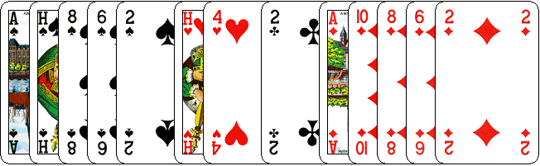

|  |  |  |  |  |
| --- | --- | --- | --- | --- |
| 1♣ | 1♦ | 1♥ | 1♠ | 1 SA |
| 2♣ | 2♦ | 2♥ | 2♠ | 2 SA |
| 3♣ | 3♦ | 3♥ | 3♠ | 3 SA |
| 4♣ | 4♦ | 4♥ | 4♠ | 4 SA |
| 5♣ | 5♦ | 5♥ | 5♠ | 5 SA |
| 6♣ | 6♦ | 6♥ | 6♠ | 6 SA |
| 7♣ | 7♦ | 7♥ | 7♠ | 7 SA |
| Pas | DB | RDB |  | |

|  |  |
| --- | --- |
| Hoe opent u deze hand? | Omcirkel uw bod |

|  |  |  |  |
| --- | --- | --- | --- |
| 7 | 14 punten | Wij | Zij |

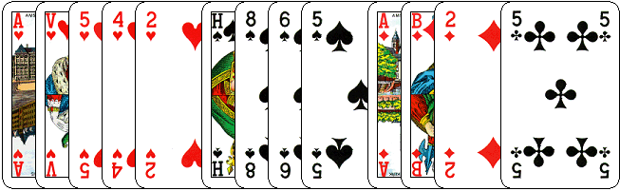

|  |  |  |  |  |
| --- | --- | --- | --- | --- |
| 1♣ | 1♦ | 1♥ | 1♠ | 1 SA |
| 2♣ | 2♦ | 2♥ | 2♠ | 2 SA |
| 3♣ | 3♦ | 3♥ | 3♠ | 3 SA |
| 4♣ | 4♦ | 4♥ | 4♠ | 4 SA |
| 5♣ | 5♦ | 5♥ | 5♠ | 5 SA |
| 6♣ | 6♦ | 6♥ | 6♠ | 6 SA |
| 7♣ | 7♦ | 7♥ | 7♠ | 7 SA |
| Pas | DB | RDB |  | |

|  |  |
| --- | --- |
| Hoe opent u deze hand? | Omcirkel uw bod |

|  |  |  |  |
| --- | --- | --- | --- |
| 8 | 12 punten | Wij | Zij |

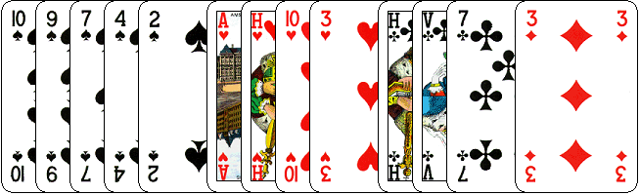

|  |  |  |  |  |
| --- | --- | --- | --- | --- |
| 1♣ | 1♦ | 1♥ | 1♠ | 1 SA |
| 2♣ | 2♦ | 2♥ | 2♠ | 2 SA |
| 3♣ | 3♦ | 3♥ | 3♠ | 3 SA |
| 4♣ | 4♦ | 4♥ | 4♠ | 4 SA |
| 5♣ | 5♦ | 5♥ | 5♠ | 5 SA |
| 6♣ | 6♦ | 6♥ | 6♠ | 6 SA |
| 7♣ | 7♦ | 7♥ | 7♠ | 7 SA |
| Pas | DB | RDB |  | |

|  |  |
| --- | --- |
| Hoe opent u deze hand? | Omcirkel uw bod |

|  |  |  |  |
| --- | --- | --- | --- |
| 9 | 16 punten | Wij | Zij |

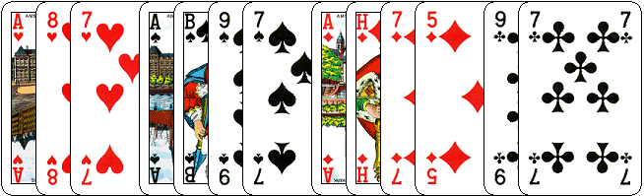

|  |  |  |  |  |
| --- | --- | --- | --- | --- |
| 1♣ | 1♦ | 1♥ | 1♠ | 1 SA |
| 2♣ | 2♦ | 2♥ | 2♠ | 2 SA |
| 3♣ | 3♦ | 3♥ | 3♠ | 3 SA |
| 4♣ | 4♦ | 4♥ | 4♠ | 4 SA |
| 5♣ | 5♦ | 5♥ | 5♠ | 5 SA |
| 6♣ | 6♦ | 6♥ | 6♠ | 6 SA |
| 7♣ | 7♦ | 7♥ | 7♠ | 7 SA |
| Pas | DB | RDB |  | |

|  |  |
| --- | --- |
| Hoe opent u deze hand? | Omcirkel uw bod |

|  |  |  |  |
| --- | --- | --- | --- |
| 10 | 17 punten | Wij | Zij |

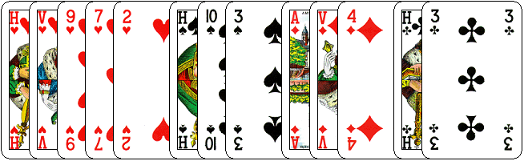

|  |  |  |  |  |
| --- | --- | --- | --- | --- |
| 1♣ | 1♦ | 1♥ | 1♠ | 1 SA |
| 2♣ | 2♦ | 2♥ | 2♠ | 2 SA |
| 3♣ | 3♦ | 3♥ | 3♠ | 3 SA |
| 4♣ | 4♦ | 4♥ | 4♠ | 4 SA |
| 5♣ | 5♦ | 5♥ | 5♠ | 5 SA |
| 6♣ | 6♦ | 6♥ | 6♠ | 6 SA |
| 7♣ | 7♦ | 7♥ | 7♠ | 7 SA |
| Pas | DB | RDB |  | |

|  |  |
| --- | --- |
| Hoe opent u deze hand? | Omcirkel uw bod |

Deze boekjes zijn ontstaan door het ontbreken van goedkoop materiaal voor huiswerk voor de cursisten.  
  
Na het eerste boekje vonden de cursisten dit zo leuk, dat ik maar de stoute schoenen heb aangetrokken en meerdere van deze boekjes ben gaan schrijven.  
  
Het enthousiasme van de cursisten heeft mij doen besluiten om deze boekjes gratis aan iedereen die ze wil hebben, beschikbaar te stellen.  
  
Wij hebben bewust geen antwoorden bij de boekjes gemaakt, waardoor deze voor elk biedsysteem te gebruiken zijn.  
  
Wij zouden het waarderen, dat u ons copyright zou laten staan.  
  
Mocht u aan of opmerkingen hebben, laat het ons dan weten.

Wij wensen u veel plezier met deze boekjes.